# FREE VIBRATION OF CANTILEVER BEAM Theory

**Learning objectives**

After completing this simulation experiment one should be able to

* Model a given real system to an equivalent simplified model of a cantilever beam with suitable assumptions / idealisations
* Calculate the stiffness of a real system which is assumed to be equivalent of a cantilever beam
* Determine the mass of the system actively participating in dynamics
* Determine the natural frequency of a given system equated to a cantilever beam
* Determine the influence of material properties like Youngs modules (E) and density (ρ ) in dynamics
* Determine the influence of cross section, length of cantilever beam in dynamics

**Cantilever Beam Introduction**

Look at the few of the real systems shown below,try to make suitable assumptions to deduce the system to a cantilever beam.

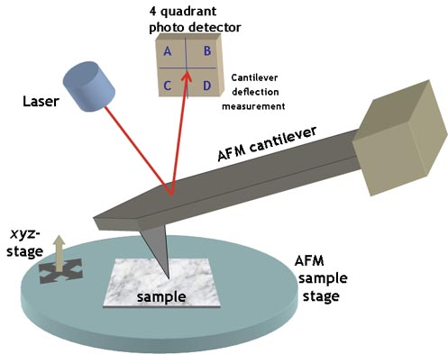An aircraft wing as a cantilever beamAn atomic force probe

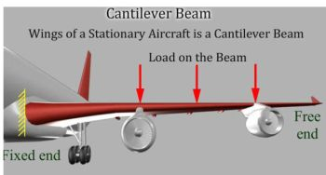

A tower crane overhang is like a cantilever beam

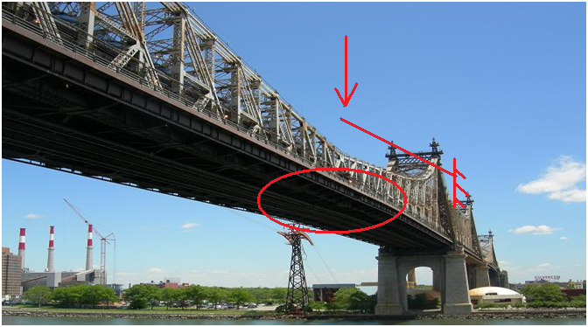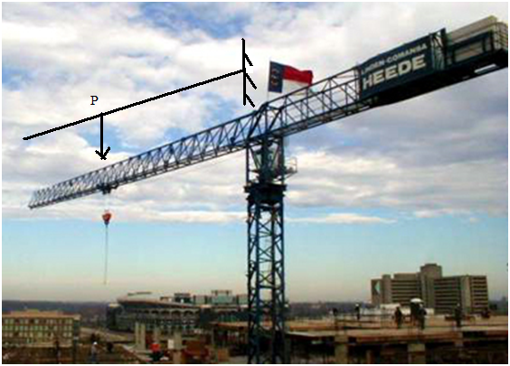

A double overhang folding bridge

A system is said to be a cantilever beam system if one end of the system is rigidly fixed to a support and the other end is free to move.

Vibration analysis of a cantilever beam system is important as it can explain and help us analyse a number of real life systems. The following few examples can be simplified to a cantilever beam, thereby helping us make design changes accordingly for the most efficient systems.

To understand the effect of free vibration on the cantilever beam, we need to understand and calculate the following parameters.

* Stiffness of the cantilever beam.
* Mass of the cantilever beam.

We can determine the stiffness of the system through simple equations from strength of material.

$$K=\frac{3EI}{L^{3}}$$

Where

K = Stiffness of system. (N/m)

E = Young s Modulus of the material. (${N/m}^{2}$)

I = Area moment of inertia. ($m^{4}$)

L = Effective length of Cantilever Beam (m)

Assumptions made during modelling and analysis:

* The mass (M) of the whole system is considered to be lumped at the free end
* No energy consuming element (damping ) present in the system ie. undamped vibration
* The complex cross section and type of material of the real system has been simplified to equate to a cantilever beam

The fundamental natural frequency $ω_{n}$, by definition is

$ω_{n}= \sqrt{\frac{K}{M}}$ (radians/second)

Since the cantilever beam is undergoing free vibration, the governing differential equation of the system considering undamped free vibration can be given by

$M\ddot{x}+Kx= 0$; $\ddot{x}+ω_{n}^{2}x=0$

Lets try to understand these equations by doing a few simple simulations, go to next tab procedure to find out how to run the simulation to EXPLORE (expR) and to EXPERIMENT (expT). A talking tutorial or a self-running demo with narration can be seen at EXPLAIN (expN)